How to Buy

Connect with our sales team:

BY PHONE

Shenzhen: +86 755 33882826
Hongkong: +852 31102497 +852 69427050

Or use the form below and a member of our sales team will contact you.

Not interested in sales? Visit our Contact Us page.
Contact us 此处需要添加超级链接到Contact us (联系我们)这个菜单页面
SALES INQUIRY FORM

First Name:

Last Name:

Email:

Phone:

Job Function:
这个job function控件菜单需要加入以下这些职位,详细如下：
Select...
Product Management
Purchasing Management
Sales & Marketing Management
Sales & Marketing Technical
Administration
Business Development Management
Business / General Management
CEO / COO / President / Owner
Executive Management

Company:

Business Type:
这个Business Type:控件菜单需要加入以下这些,详细如下：
Select...
Consultant
Large Enterprise
Small / Medium Enterprise
Service Provider
Partner
Distributor / Wholesaler / Retailer

Country:
这个Country:控件菜单需要加入以下这些,详细可以参考如下：
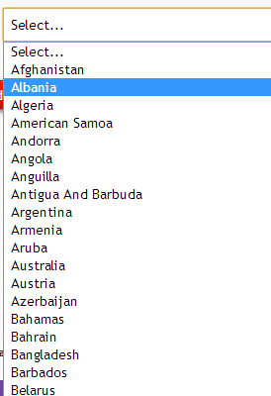

What is your timeframe to purchase? :
这个What is your timeframe to purchase?控件菜单需要加入以下这些,详细如下:
Select...
0 – 3 Months
4 – 6 Months
7 – 12 Months
Over 12 Months
No Project Now

What is your estimate budge (in US$)? :
Select...
0 – 99K
100 – 249K
250 – 499K
500 – 1M
Over 1M
No Specified

Comments:

Yes,i would like to receive information about cellularmega.hk offering by email ☑

Submit Reset

Cellularmega.hk Global Privacy and Data Protection Policy
此处需要添加超级链接到Cellularmega.hk Global Privacy and Data Protection Policy,内容请见此文件夹中的WORD文档

